1095 C Overview & COBRA Rights
These are copies of my own 1095 forms. It’s a standardized form. The codes are consistent between employers. The differences are in how the data is extracted from different HR systems. I can explain the differences in my forms as the recipient.

Year 2017
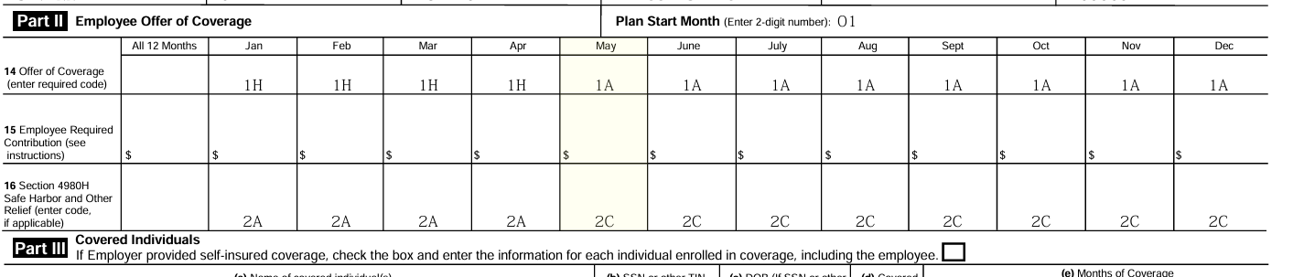
In 2017, my employer spun off into its new company. The effective date was May 1, 2017. As a result, the first 4 months of 2017 were 1H, since technically, I had no health coverage by the new company. 2A is normally partnered with 1H as a sign of not employed.

Years 2018-2023
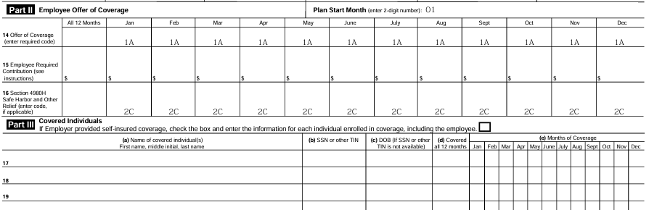
For a majority of my time employed, my health coverage reflected as 1A/2C. 1A represented the fact that the cheapest plan my company offered its employees met the Minimum Essential Coverage (MEC) and Minimum Value (MV) as determined by the IRS. 2C meant I was covered.

Year 2024
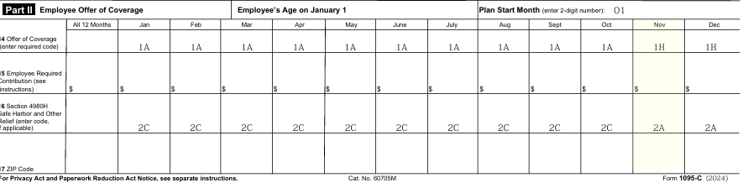
I was laid off in 2024. It occurred in October 2024. My company covered the rates I would pay for the rest of October. Thus, with this free period of coverage, my form appeared as 1A 2C. Come November 2024, I swapped back to the 1H/2A codes. My had coverage, but it was not MEC/MV.
Year 2025
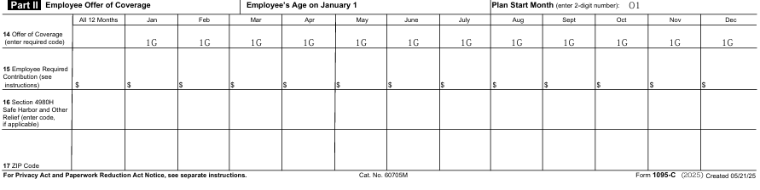
I have a 1G for 2025. I was never employed by my ex-employer in 2025. However, my COBRA status comes into play with this code. 1G is Non-Full-Time Employee. However, since my COBRA eligible coverage period lasts from November 1, 2024, to April 30, 2026, I was technically offered coverage.
Once my company subsidy ran out, I chose to end coverage. Well, I was willing to keep my dental, vision, and EAP coverage, but I could not do so. The company’s portal did not allow me to choose to drop a plan. They require calling into the service center. I don’t think the service center understood my COBRA rights. They wouldn’t let drop my medical plan and continue my other plans. Each plan had a separate COBRA right. I should have been able to drop medical once the subsidy ran out but continue the other 3 plans when it increased to the 102% rate. When I paid only for the 3 plans I wanted to keep, they ran their termination event to cancel all my plans. I could go more into my personal COBRA issues, but it’s not worth the effort.
COBRA did make an impact on codes for those covered in COBRA while employed, as well as the employees that didn’t meet the MEC+MV. For that population, they got on Line 14, a 1B, 1C, and 1D based on who was offered a plan. It was aligned with whom was offered coverage. Singles received a 1B, couples 1C, and families or children only scenarios received a 1D. These codes came into play for those with plans that exceeded MEC+MV as well.
It’s been a while since have worked with 1095C, but it’s a complex processing to begin with.

